### BIOLOGY TEST ONE

Name: ____________________ Teacher: Mr Lafferty Mark: /52

**Percentage: %**

**SECTION A: MULTIPLE CHOICE (14 marks)**

**Select the most correct answer for each question below.**

**Please circle your answer on the multiple choice answer grid below.**

1. A B C D 11. A B C D

2. A B C D 12. A B C D

3. A B C D 13. A B C D

4. A B C D 14. A B C D

5. A B C D

6. A B C D

7. A B C D

8. A B C D

9. A B C D

10. A B C D

**1.** Ribosomes help the cell by:

(a) Making proteins.

(b) Making energy.

(c) Removing wastes.

(d) Storing wastes.

**2.** Choose the correct definition for ‘microscopic’.

(a) A scientific piece of equipment.

(b) An object made of atoms.

(c) So small that can only be seen using a microscope.

(d) A type of magnifying lens.

**3.** Choose the correct definition for ‘magnified’.

(a) Made brighter.

(b) Made clear.

(c) Made smaller.

(d) Made bigger.

**4.** Choose the correct definition for chloroplast.

(a) Part of a plant cell that makes food using energy from the sun.

(b) Part of an animal cell that makes food using energy from the sun.

(c) An inverted specimen.

(d) The object being looked at through a microscope.

**5.** Choose the correct definition for ‘specimen’.

(a) The slide with film.

(b) The object being looked at through a microscope.

(c) Plant or animal cells.

(d) The small structures found inside a living cell.

**6.** The study of living things is called:

(a) Biology.

(b) Butchery.

(c) Dissection.

(d) Intersection.

**7.** What cell organelle makes energy for the cell?

(a) Endoplasmic reticulum.

(b) Mitochondria.

(c) Ribosomes.

(d) Nucleus.

**8.** The diameter (width) of the image that can be seen through the microscope is called the:

(a) Field of view.

(b) Magnification.

(c) Illumination.

(d) Image.

**9.** The rigid part that surrounds a plant cell, giving it shape and strength, is called:

(a) Chloroplast.

(b) Cell wall.

(c) Cell membrane.

(d) Control centre.

**10.** The plant cell structure where things are stored is called:

(a) Chloroplast.

(b) Vacuole.

(c) Cytoplasm.

(d) Green plant.

**11.** Microscopic means:

(a) so small it can only be seen with a telescope.

(b) so small it can only be seen with a microscope.

(c) so big it can only be seen with a telescope.

(d) so far away it can only be seen with a telescope.

**12.** Kevin sets up a specimen on a microscope slide. He puts the specimen onto the slide and then covers the specimen with a:

(a) cover slip

(b) towel

(c) beaker

(d) funnel

**13.** Name the part of cells that is a watery jelly-like liquid that all the organelles float in.

(a) Chlorophyll.

(b) Chloroplast.

(c) Cytoplasm.

(d) Plasma.

**14.** Select the **incorrect** statement.

(a) The coarse focus knob moves the microscope tube up and down.

(b) The stage clips hold the slide in place on the stage.

(c) The objective lens is the part of the microscope you look through.

(d) The fine focus knob is used to make fine adjustments on the focus.

**SECTION B: SHORT ANSWER (38 marks)**

**1.** Label the diagram of the animal cell below. (8 marks)

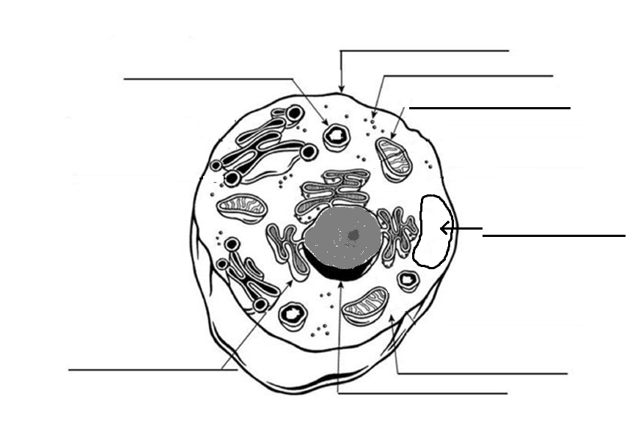

**2.** Label the diagram of the plant cell below. (9 marks)

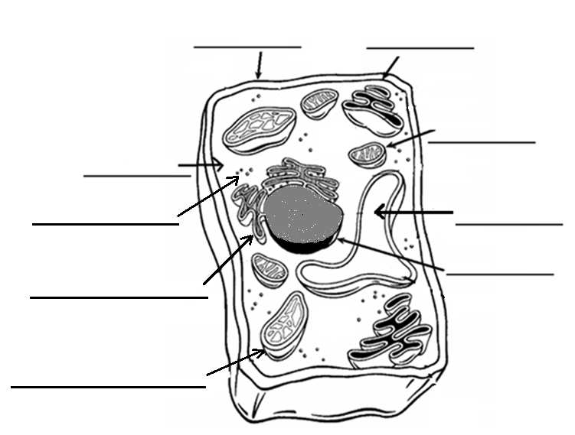

**3.** Explain two main difference between an animal cell and a plant cell. (2marks)

_____________________________________________________________________________________

_____________________________________________________________________________________

_____________________________________________________________________________________

_____________________________________________________________________________________

_____________________________________________________________________________________

_____________________________________________________________________________________

_____________________________________________________________________________________

**4.** Label the diagram of the microscope below. (9 marks)

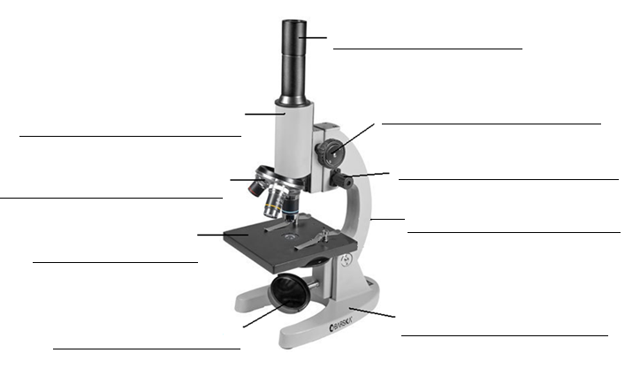

**5**. Mandy has a microscope that the eyepiece lens of x10 magnification and the objective lens of x20 magnification. What will the total magnification be? Show your working.

(2 marks)

**6.** Fill in the table below. (2 marks)

|  |  |
| --- | --- |
| **Organelle** | **Function** |
| Nucleus |  |
|  | Controls what gets into and out of the cell |

**7.** Describe how you would safely carry a microscope. (2 marks)

_____________________________________________________________________________________

_____________________________________________________________________________________

_____________________________________________________________________________________

**8.** Circle either true or false for the following statements. (4 marks)

There are only two types of cells. True False

You can see most cells without a microscope. True False

Plants have organelles that animals do not. True False

The higher the microscope magnification, the smaller True False

the microscope field of view will be.